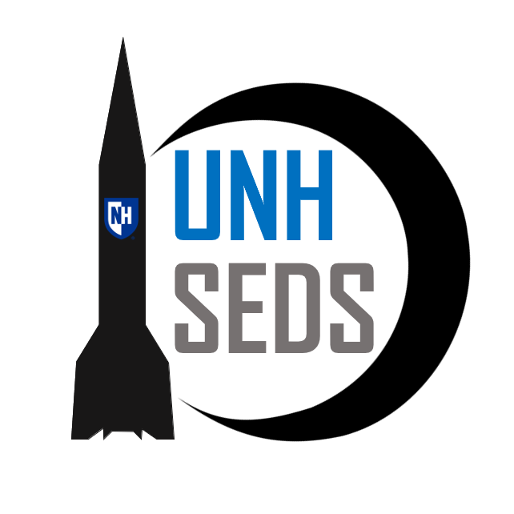

University of New Hampshire –

Students for the Development and Exploration of Space

High Power Rocketry

H

JOIN OUR ORGANIZATION!

User

UNH SEDS  8 College Road, Durham NH, 03824

UNH SEDS

# Who We Are

UNH SEDS is part of a nation-wide organization dedicated to educating students about space exploration and development. UNH SEDS designs and manufactures many engineering projects every year with the goal to give all its members a well-rounded experience, no matter the major.

Founded in February of 2017 and paired with a dedicated faculty advisor along with a committed group of students, we will only grow. As of Fall 2017, we have a committed club roster of over 20 students in six different majors.

Combined with outreach events and a large underclassmen student body, UNH SEDS has potential to grow into an even more efficient and productive organization.

# Yearly Goals

As UNH SEDS continues to grow, many non-engineering and engineering projects want to be accomplished. Although some SEDS groups across the nation have different focus areas, such as outreach or networking, UNH SEDS is dedicated to pushing the bounds of our current knowledge to design, manufacture and test a wide range of space related technologies. With the combination of determined members and the connections of a nationwide organization we can expand and successfully run a student based organization in pursuit of knowledge in high power rocketry.

## Non-Engineering Goals

* Plan outreach events to entice the younger generations of our community in the fields of STEM and the exploration of space.
* Establish a stronger connection with nearby SEDS chapter at other universities.
* Participate in Space Vision hosted by a university each year to connect all nationwide SEDS chapters (November 2018 in San Diego, California).
* Expand on a more comfortable learning environment for all members, no matter the major or year.

## Engineering Goals

* Design, manufacture and test a high-altitude hybrid rocket to perform in the University Student Rocketry Competition in Florida during May of next year.
* Continue our simulation and optimization work on rocket dimensions and dynamics in flight using MATLAB.
* Host monthly teaching sessions to learn a new topic in the subject of astronomy, engineering or business from outside professionals.

# Sponsorship Opportunities

Beyond the support provided by the CEPS deans office, UNH SEDS relies heavily on donations from individuals and businesses. Monetary donations are used to purchase and maintain shop equipment, purchase parts, and pay for business and travel expenses. In addition to monetary donations, materials, discounts, and services are also appreciated. Service donations allow our team to have professional fabrication beyond the capabilities of our machine shop

## Who You Will Help

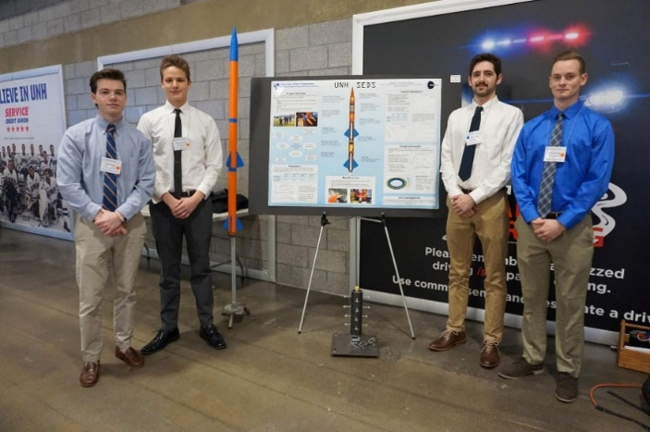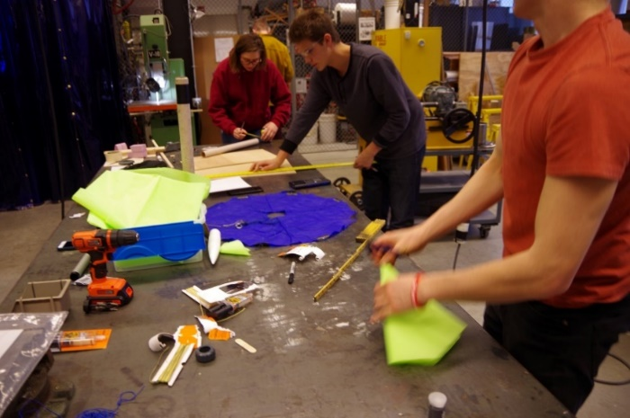Our club consists of students across a multitude of ages and majors. We bring together underclassmen with an interest in space and rocket technologies, and we have created a team of competent individuals who work together as a team. Students from Mechanical Engineering, Chemical Engineering, Engineering Physics, Electrical Engineering, Computer Science and more all participate in the club in some capacity, expanding the reach of sponsorship benefits across multiple departments.

With our clear engineering and no-engineering related goals come large monetary expenses. We are reaching out to you and your company for assistance to enable us to continue our work in a field that has continued to expand since the Apollo era.

Below is the contact information of our Founder and President if you are interested in more information on what UNH SEDS is all about. Detailed on the next page are the other benefits that your business will receive in return for your sponsorship.

## Contact Information

If you would like to support us or have any questions, please contact Charlie Nitschelm below:

**Charlie Nitschelm**

[Cjn1012@wildcats.unh.edu](mailto:Cjn1012@wildcats.unh.edu)

603-923-9079

## Sponsorship Breakdown

Sponsorship Breakdown